Options Implied Volatility: Smile, Surface & Covered-Call Overlay

Author: HARSH BYJASH | Date: 2025-10-01

# 1. Objective

Compute implied volatilities from an options chain, visualize the volatility smile and surface, and compare a covered-call overlay to buy-and-hold.

# 2. Data

Synthetic options chain with strikes 320–480 and maturities 30–180 days; underlying price 400; risk-free rate 2%.

# 3. Method

Derived implied vols via bisection on Black–Scholes prices. Visualized smile (nearest maturity) and full surface (strike × maturity). Toy backtest compares monthly covered-call returns to buy-and-hold to illustrate income vs upside tradeoff.

# 4. Results

Figures show put skew (higher IV for lower strikes) and term structure effects. The covered-call overlay produced a smoother equity path but capped upside.

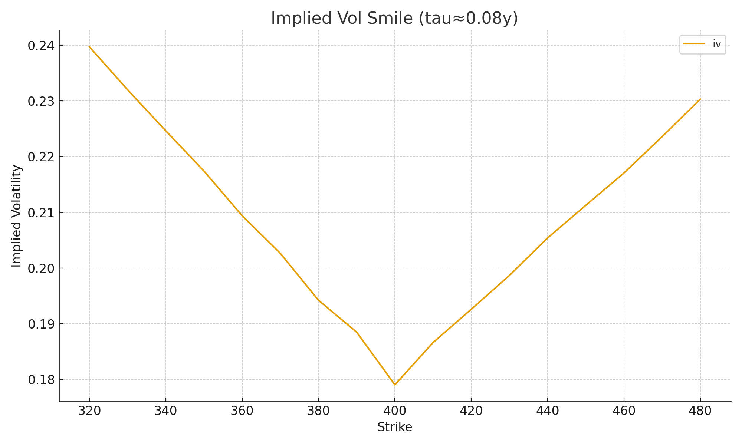

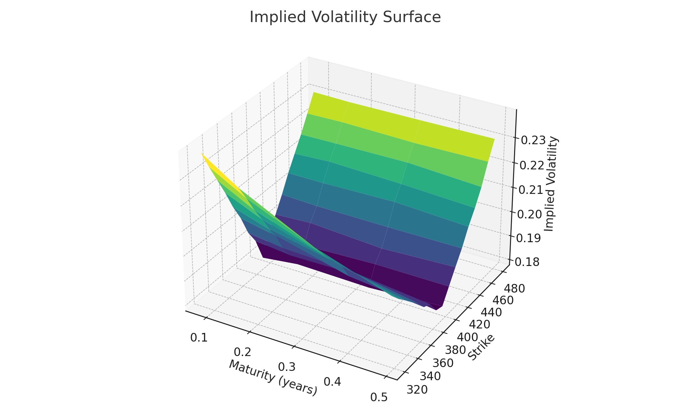

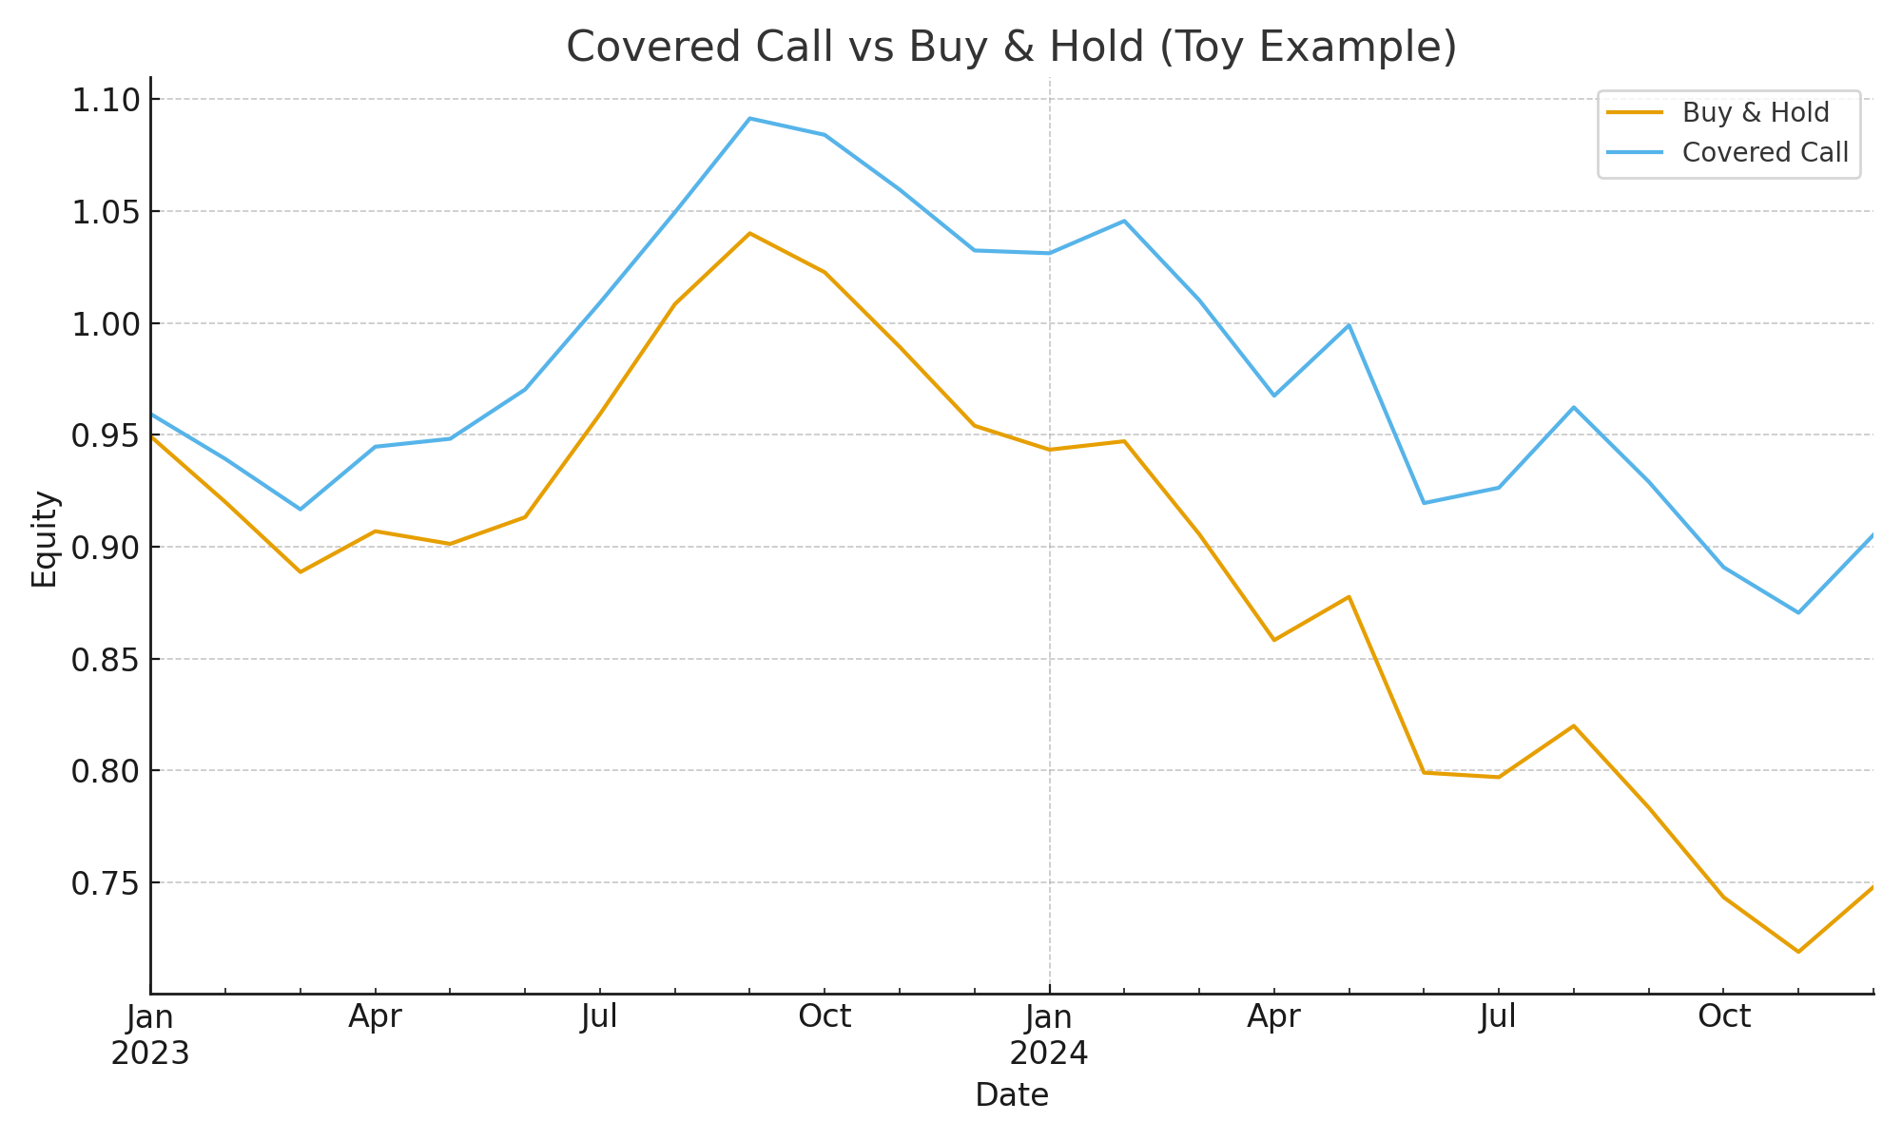

# 5. Interpretation

Implied volatility skew reflects asymmetric crash risk pricing. Covered calls trade upside for premium income; performance depends on realized volatility vs implied.

# 6. Limitations

Synthetic data; no transaction costs or assignment risk; dividends ignored. Real backtests need daily options data and execution assumptions.

# 7. Next Steps

Use real SPY option chains, construct delta-based strikes, and test rules across multiple regimes.